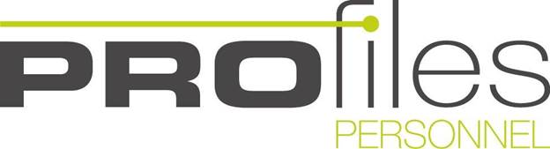

COVID 19 Information for Temporary Workers

The Government has introduced strict measures to reduce the spread of coronavirus, including curbing people’s movement outside their homes, banning public gatherings of more than two people and the closure of shops selling non-essential items.
In addition, the Government has shut all UK social venues including restaurants, cafés, bars, pubs, health clubs and leisure centres. The new social distancing measures will be reviewed by the Government every month to see if any can be relaxed.
We realise that this has impacted on your earning opportunities but rest assured we are doing everything we can to access any government finance to support workers on zero hours contracts but at present we don’t have clarification on this. Announced is help for all Self Employed Workers which we welcome.
We know that the next weeks and months are going to present new and unexpected challenges. All industries and particularly the events industry is taking a massive hit, but we are still here to support you across the Commercial, Industrial and Events Division should you have any queries or looking for alternative opportunities. At present we are manning our phones 01252 723442 but working remotely.
We are trying to encourage all our temporary staff to complete their records on our database to ensure you are compliant and ready to go when the restrictions are lifted. If you have already registered please go onto our portal and complete your record https://online.profiles-personnel.com/login. We need your headshot, passport and CV and please fill in the Details section. . If you are looking for Events work we have a wonderful app – Liveforce – if you are not on it let us know theo@profiles-personnel.com If you complete your details you will get first choice of the best events. We are encouraging our temporary staff who are registered to our Events & Hospitality division to complete their Flow Training online and once completed you will receive an official certificate for Health & Safety, Food Safety, Food Allergens and Venue Specific Training. We will be adding other training courses to upskill you and will keep you informed. This training can be carried out online and is free. Contact theo@profiles-personnel.com
Watch our Blog – we will be adding advice on ‘A CV that will be noticed amongst the crowd’ ‘Interviews – what’s important’ These blogs will be written by our Consultants who have at least 20 years experience in the Permanent and Temporary Commercial Industry.
If you need help please click on this link for the latest information
Support for Employees: https://www.gov.uk/government/publications/guidance-to-employers-and-businesses-about-covid-19/covid-19-guidance-for-employees
This government link will assist you with all the information that you need during the Covid19 virus but please feel free to contact us if we can help further.
As a team we are working as hard as ever to deliver the best service possible. Everyone please stay safe and healthy your Profiles Team

